**SIMATS ENGINEERING**

**DSA0201**

**COMPUTER VISION WITH OPENCV FOR ROBOTICS AND AUTOMATION**

**M.MAHATHI**

**192324098**

**Artificial Intelligence and Data Science**

**Lab manual**

**1.Perform basic Image Handling and processing operations on the image. Read an image in python and Convert an Image to Grayscale.**

**AIM:**

To Convert an Image to Grayscale Image using python**.**

**PROGRAM:**

!pip install opencv-python-headless matplotlib

from google.colab import files

uploaded = files.upload()

import cv2

import matplotlib.pyplot as plt

image_path = next(iter(uploaded)) *# Get the uploaded image name*

image = cv2.imread(image_path)

image_rgb = cv2.cvtColor(image, cv2.COLOR_BGR2RGB)

plt.imshow(image_rgb)

plt.axis('off')

plt.show()

**INPUT:**

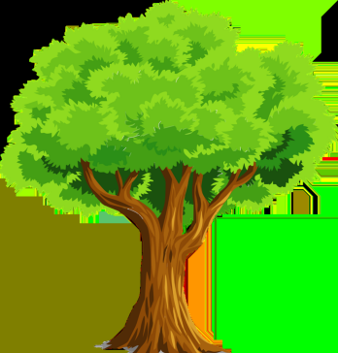

**OUTPUT:**

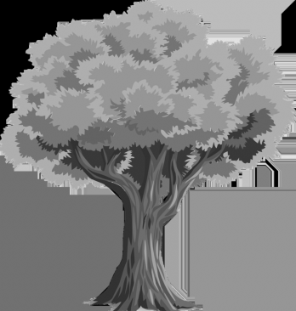

**2.Perform basic Image Handling and processing operations on the image.Read an image in python and Convert an Image to Blur using GaussianBlur.**

**AIM:**

To perform basic image processing operations to read an image in Python and convert it to a blurred version using GaussianBlur.

**PROGRAM:**

!pip install opencv-python-headless matplotlib

from google.colab import files

uploaded = files.upload()

import cv2

import matplotlib.pyplot as plt

image_path = next(iter(uploaded)) *# Get the uploaded image name*

image = cv2.imread(image_path)

image_rgb = cv2.cvtColor(image, cv2.COLOR_BGR2RGB)

plt.imshow(image_rgb)

plt.axis('off')

plt.show()

image_blur = cv2.GaussianBlur(image, (5, 5), 0)

image_blur_rgb = cv2.cvtColor(image_blur, cv2.COLOR_BGR2RGB)

plt.imshow(image_blur_rgb)

plt.axis('off')

plt.show()

cv2.imwrite('blurred_image.jpg', image_blur)

**INPUT: OUTPUT:**

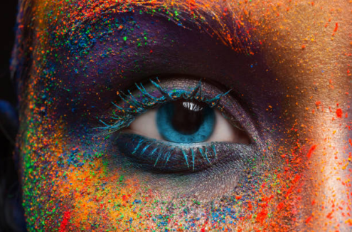 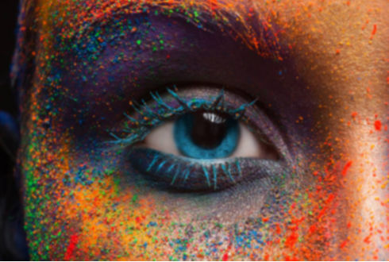

**3.Perform basic Image Handling and processing operations on the image. Read an image in python and Convert an Image to show outline using Canny function.**

**AIM:**

To perform basic image processing operations to read an image in Python and convert it to show outlines using the Canny edge detection function.

**PROGRAM:**

!pip install opencv-python-headless matplotlib

from google.colab import files

uploaded = files.upload()

import cv2

import matplotlib.pyplot as plt

image_path = next(iter(uploaded))

image = cv2.imread(image_path)

image_rgb = cv2.cvtColor(image, cv2.COLOR_BGR2RGB)

plt.imshow(image_rgb)

plt.axis('off')

plt.show()

image_gray = cv2.cvtColor(image, cv2.COLOR_BGR2GRAY)

edges = cv2.Canny(image_gray, threshold1=100, threshold2=200)

plt.imshow(edges, cmap='gray')

plt.axis('off')

plt.show()

cv2.imwrite('edges_image.jpg', edges)

**INPUT:**

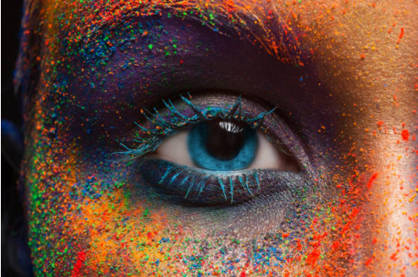

**OUTPUT:**

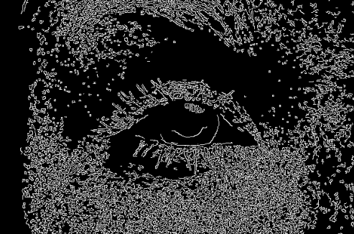

**4.Perform basic Image Handling and processing operations on the image. Read an image in python and Dilate an Image using Dilate function.**

**AIM:**

To perform basic image processing operations to read an image in Python and dilate it using the cv2.dilate() function to enhance or thicken features.

**PROGRAM:**

Install necessary libraries

!pip install opencv-python-headless matplotlib

Upload the image

from google.colab import files uploaded = files.upload()

Import necessary libraries

import cv2 import matplotlib.pyplot as plt

Read the image

image_path = next(iter(uploaded))

image = cv2.imread(image_path)

Convert the image to RGB (for displaying with Matplotlib)

image_rgb = cv2.cvtColor(image, cv2.COLOR_BGR2RGB)

Display the original image

plt.imshow(image_rgb) plt.axis('off') plt.show()

Convert the image to grayscale (needed for dilation operation)

image_gray = cv2.cvtColor(image, cv2.COLOR_BGR2GRAY)

Create a kernel (a 5x5 matrix of ones)

kernel = cv2.getStructuringElement(cv2.MORPH_RECT, (5, 5))

image_dilated = cv2.dilate(image_gray, kernel, iterations=1)

Display the dilated image

plt.imshow(image_dilated, cmap='gray') plt.axis('off') plt.show()

(Optional) Save the dilated image

cv2.imwrite('dilated_image.jpg', image_dilated)

**INPUT:**

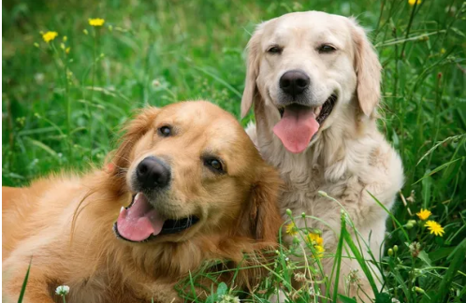

**OUTPUT:**

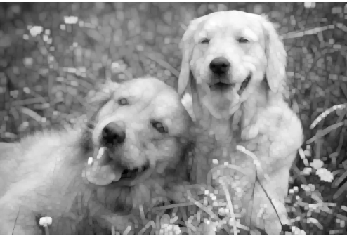

**5. Perform basic Image Handling and processing operations on the image.Read an image in python and Erode an Image using erode function.**

**AIM:**

To perform basic image processing operations to read an image in Python and erode it using the cv2.erode() function to shrink or thin features.

**PROGRAM:**

!pip install opencv-python-headless matplotlib

from google.colab import files

uploaded = files.upload()

import cv2

import matplotlib.pyplot as plt

image_path = next(iter(uploaded)) *# Get the uploaded image name*

image = cv2.imread(image_path)

image_rgb = cv2.cvtColor(image, cv2.COLOR_BGR2RGB)

plt.imshow(image_rgb)

plt.axis('off')

plt.show()

image_gray = cv2.cvtColor(image, cv2.COLOR_BGR2GRAY)

kernel = cv2.getStructuringElement(cv2.MORPH_RECT, (5, 5)) *# You can adjust the size*

image_eroded = cv2.erode(image_gray, kernel, iterations=1)

plt.imshow(image_eroded, cmap='gray')

plt.axis('off')

plt.show()

cv2.imwrite('eroded_image.jpg', image_eroded)

**INPUT: OUTPUT:**

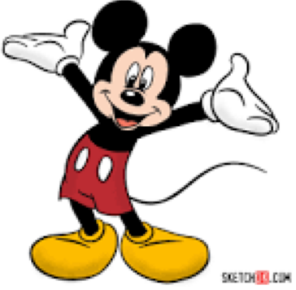 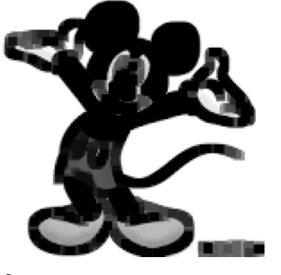

**6. Perform basic video processing operations on the captured video.Read captured video in python and display the video, in slow motion and in fast motion.**

**AIM:**

To perform basic video processing operations to read a captured video in Python and display it in normal, slow motion, and fast motion by controlling the frame delay.

**PROGRAM:**

import cv2

video_path 'video.mp4" #Replace with your video file

cap cv2.VideoCapture(video_path)

If not cap.isOpened():

print("Cannot open video")

exit()

def

play_video(speed label, delay):

print("Playing (speed_label] video. Press 'g' to quit.")

cap.set(cv2.CAP_PROP_POS_FRAMES, 0)

while True:

ret, frame cap.read()

If not ret:

break

cv2.imshow("Video", frame)

if cv2.waitKey(delay) & 0xFF ord('a'):

break

cv2.destroyAllWindows()

for label, delay in [('normal', 30), ('slow motion, 120), ('fast motion', 5)]:

play_video(label, delay)

cop.release()

**OUTPUT:**

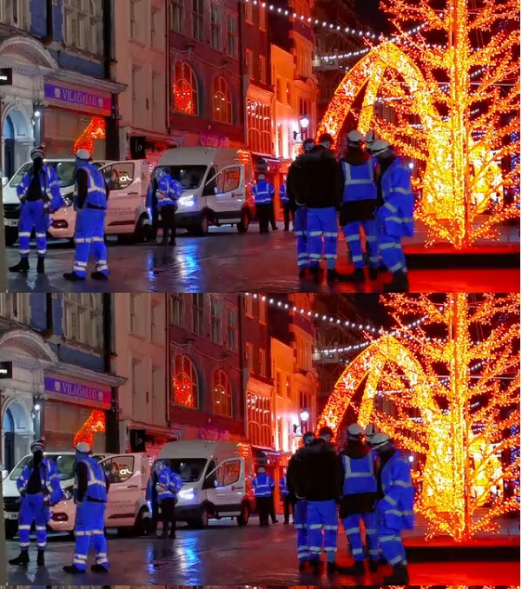

**7. Capture video from web Camera and Display the video, in slow motion and in fast motion.**

**AIM:**

To perform basic image handling operations to read an image in Python and scale it to both larger and smaller sizes while maintaining aspect ratio.

**PROGRAM:**

import cv2

import time

cap = cv2.VideoCapture(0)

if not cap.isOpened():

print("Webcam not accessible.")

exit()

speed=1# Default to normal speed

print("Press 's' slow, 'f' = fast, 'n' = normal, 'q' = quit.")

while True:

ret, frame cap.read()

if not ret:

break

cv2.imshow('Webcam', frame)

time.sleep(speed)

key= cv2.waitKey(1) & 0xFF

if key == ord('q'):

break

elif key == ord('s'):

speed = 0.1

elif key == ord('f'):

speed 0.01

elif key == ord('n'):

speed = 1

cap.release() cv2.destroyAllWindows()

**INPUT:**

**8. Scaling an image to its Bigger and Smaller sizes.**

**AIM:**

To perform basic image handling operations to read an image in Python and scale it to both larger and smaller sizes while maintaining aspect ratio.

**PROGRAM:**

!pip install opencv-python

import cv2

import matplotlib.pyplot as plt

from google.colab import files

uploaded = files.upload()

import io

import numpy as np

image_path = next(iter(uploaded))

image = cv2.imdecode(np.frombuffer(uploaded[image_path], np.uint8), cv2.IMREAD_COLOR)

image = cv2.cvtColor(image, cv2.COLOR_BGR2RGB) *# Convert from BGR to RGB for display*

smaller = cv2.resize(image, (0, 0), fx=0.5, fy=0.5)

bigger = cv2.resize(image, (0, 0), fx=2, fy=2)

plt.figure(figsize=(12, 6))

plt.subplot(1, 3, 1)

plt.imshow(image)

plt.title('Original')

plt.axis('off')

plt.subplot(1, 3, 2)

plt.imshow(smaller)

plt.title('Smaller (20%)')

plt.axis('off')

plt.subplot(1, 3, 3)

plt.imshow(bigger)

plt.title('Bigger (100%)')

plt.axis('off')

plt.tight_layout()

plt.show()

**INPUT:**

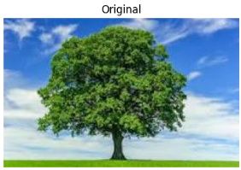

**OUTPUT:**

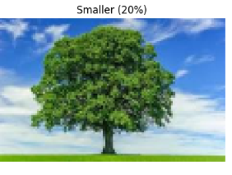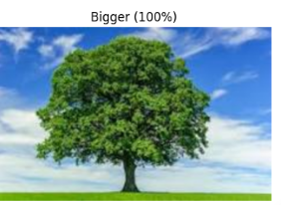

**9.Perform Rotation of an image to clockwise and counter clockwise direction.**

**AIM:**

To perform basic image rotation operations to read an image in Python and rotate it in both clockwise and counter-clockwise directions by specified angles.

**PROGRAM:**

!pip install pillow

from PIL import Image

from google.colab import files

from IPython.display import display

uploaded = files.upload()

image_path = next(iter(uploaded))

img = Image.open(image_path)

clockwise_img = img.rotate(-90, expand=True)

display(clockwise_img)

counterclockwise_img = img.rotate(90, expand=True)

display(counterclockwise_img)

**INPUT:**

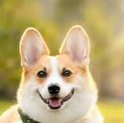

**OUTPUT:**

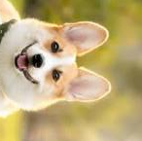 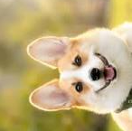

1. **Perform moving of an image from one place to another.**

**AIM:**

To perform moving of an image from one place to another.

**PROGRAM:**

!pip install pillow

from PIL import Image

from google.colab import files

from IPython.display import display

uploaded = files.upload()

image_path = next(iter(uploaded))

img = Image.open(image_path)

crop_box = (50, 50, 200, 200)

cropped_region = img.crop(crop_box)

new_location = (0,100)

img.paste(cropped_region, new_location)

display(img)

**INPUT:**

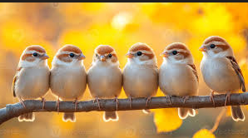

**OUTPUT:**

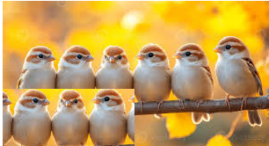

**11. Perform Affine Transformation on the image.**

**AIM:**

To apply an affine transformation (such as scaling, rotation, or translation) to the image.

**PROGRAM:**

import cv2

import numpy as np

import matplotlib.pyplot as plt

from google.colab import files

uploaded = files.upload()

image_path = next(iter(uploaded))

image = cv2.imread(image_path)

image_rgb = cv2.cvtColor(image, cv2.COLOR_BGR2RGB)

pts1 = np.float32([[50, 50], [200, 50], [50, 200]])

pts2 = np.float32([[100, 100], [25, 50], [10, 150]])

matrix = cv2.getAffineTransform(pts1, pts2)

transformed_image = cv2.warpAffine(image, matrix, (image.shape[1], image.shape[0]))

transformed_image_rgb = cv2.cvtColor(transformed_image, cv2.COLOR_BGR2RGB)

plt.figure(figsize=(10, 5))

*# Original Image*

plt.subplot(1, 2, 1)

plt.imshow(image_rgb)

plt.title("Original Image")

plt.axis('off')

*# Transformed Image*

plt.subplot(1, 2, 2)

plt.imshow(transformed_image_rgb)

plt.title("Affine Transformed Image")

plt.axis('off')

plt.show()

**INPUT:**

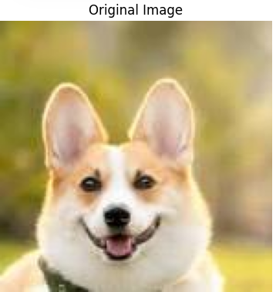

**OUTPUT:**

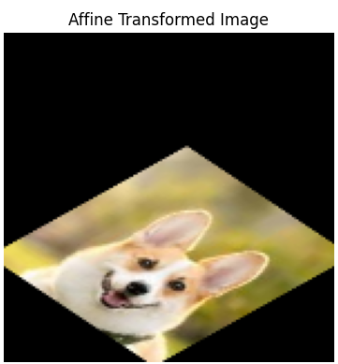

**12. Perform Perspective Transformation on the image.**

**AIM:**

To apply a perspective transformation to the image to change its viewpoint or correct distortions.

**PROGRAM:**

import cv2

import numpy as np

import matplotlib.pyplot as plt

from google.colab import files

uploaded = files.upload()

image_path = next(iter(uploaded))

image = cv2.imread(image_path)

image_rgb = cv2.cvtColor(image, cv2.COLOR_BGR2RGB)

pts1 = np.float32([[50, 50], [400, 50], [50, 400], [400, 400]])

pts2 = np.float32([[10, 100], [450, 50], [100, 450], [450, 450]])

matrix = cv2.getPerspectiveTransform(pts1, pts2)

transformed_image = cv2.warpPerspective(image, matrix, (image.shape[1], image.shape[0]))

transformed_image_rgb = cv2.cvtColor(transformed_image, cv2.COLOR_BGR2RGB)

plt.figure(figsize=(10, 5))

*# Original Image*

plt.subplot(1, 2, 1)

plt.imshow(image_rgb)

plt.title("Original Image")

plt.axis('off')

*# Transformed Image*

plt.subplot(1, 2, 2)

plt.imshow(transformed_image_rgb)

plt.title("Perspective Transformed Image")

plt.axis('off')

plt.show()

**INPUT:**

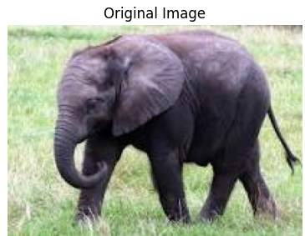

**OUTPUT:**

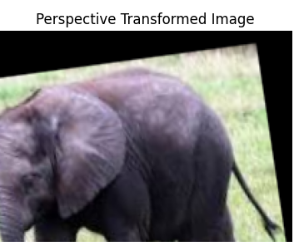

**13. Perform Perspective Transformation on the Video.**

**AIM:**

To apply perspective transformation to a video stream for viewpoint correction or distortion adjustment.

PROGRAM:

import cv2

import os

from google.colab import files

from google.colab.patches import cv2_imshow

from IPython.display import clear_output

def upload_videos():

print("Please upload your video files (e.g., 1.mp4, 2.mp4, etc.)")

print("Note: You can select multiple files at once")

uploaded = files.upload()

if not uploaded:

print("No files were uploaded. Please try again.")

return None

if not os.path.exists('/content/videos'):

os.makedirs('/content/videos')

for filename in uploaded.keys():

os.rename(f'/content/{filename}', f'/content/videos/{filename}')

clear_output()

print(f"Successfully uploaded {len(uploaded)} video(s):")

for filename in uploaded.keys():

file_size = os.path.getsize(f'/content/videos/{filename}')/1024/1024

print(f"- {filename} ({file_size:.2f} MB)")

return list(uploaded.keys())

def play_videos(video_files):

for video_file in video_files:

video_path = f'/content/videos/{video_file}'

cap = cv2.VideoCapture(video_path)

if not cap.isOpened():

print(f"Cannot open video: {video_file}")

continue

print(f"\nNow playing: {video_file}")

print("Press 'q' to quit or 'n' for next video")

while True:

ret, frame = cap.read()

if not ret:

print("End of video reached")

break

frame_rgb = cv2.cvtColor(frame, cv2.COLOR_BGR2RGB)

cv2_imshow(frame_rgb)

key = cv2.waitKey(30) & 0xFF

if key == ord('q'): # Quit entirely

cap.release()

cv2.destroyAllWindows()

return

elif key == ord('n'): # Next video

break

cap.release()

cv2.destroyAllWindows()

video_files = upload_videos()

if video_files:

play_videos(video_files)

print("\nPlayback complete. Temporary files will be deleted when Colab session ends.")

else:

print("No videos available for playback.")

**OUTPUT:**

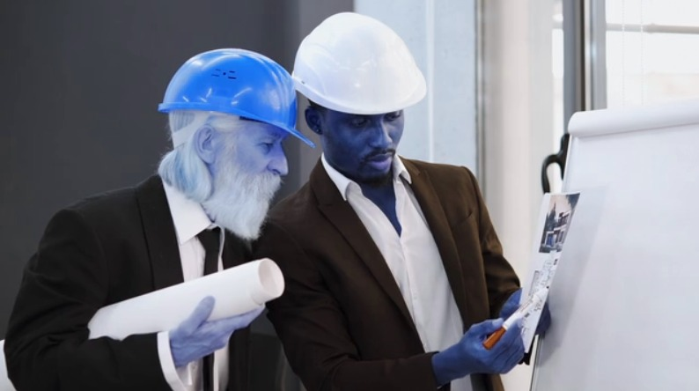

**14. Perform transformation using Homography matrix.**

**AIM:**

To apply geometric transformation to an image/video using a homography matrix for perspective correction or alignment.

**PROGRAM:**

import cv2

import numpy as np

import matplotlib.pyplot as plt

from google.colab import files

uploaded = files.upload()

image_path = next(iter(uploaded))

image = cv2.imread(image_path)

image_rgb = cv2.cvtColor(image, cv2.COLOR_BGR2RGB)

pts1 = np.float32([[50, 50], [200, 50], [50, 200], [200, 200]])

pts2 = np.float32([[10, 100], [250, 50], [100, 250], [250, 250]])

matrix, mask = cv2.findHomography(pts1, pts2)

height, width = image.shape[:2]

transformed_image = cv2.warpPerspective(image, matrix, (width, height))

transformed_image_rgb = cv2.cvtColor(transformed_image, cv2.COLOR_BGR2RGB)

plt.figure(figsize=(10, 5))

*# Original Image*

plt.subplot(1, 2, 1)

plt.imshow(image_rgb)

plt.title("Original Image")

plt.axis('off')

*# Transformed Image using Homography*

plt.subplot(1, 2, 2)

plt.imshow(transformed_image_rgb)

plt.title("Homography Transformed Image")

plt.axis('off')

plt.show()

**INPUT:**

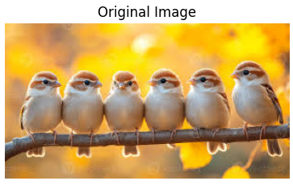

**OUTPUT:**

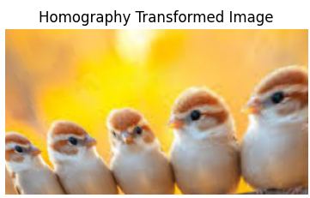

**15. Perform transformation using Direct Linear Transformation.**

**AIM:**

To compute and apply a geometric transformation using Direct Linear Transformation (DLT) for accurate image alignment or 3D reconstruction.

**PROGRAM:**

import numpy as np

xy1 = np.array([[0, 0], [1, 0], [1, 1], [0, 1]])

xy2 = np.array([[0, 0], [2, 0], [2, 2], [0, 2]])

N = xy1.shape[0]

A = []

for i in range(N):

x1, y1 = xy1[i]

x2, y2 = xy2[i]

A.append([-x1, -y1, -1, 0, 0, 0, x1*x2, y1*x2, x2])

A.append([0, 0, 0, -x1, -y1, -1, x1*y2, y1*y2, y2])

A = np.array(A)

_, _, VT = np.linalg.svd(A)

h = VT[-1]

H = h.reshape(3, 3)

print("Homography Matrix:")

print(H)

ones = np.ones((xy1.shape[0], 1))

xy1_homogeneous = np.hstack((xy1, ones))

xy2_homogeneous = xy1_homogeneous @ H.T

xy2_transformed = xy2_homogeneous[:, :2] / xy2_homogeneous[:, 2].reshape(-1, 1)

print("Transformed Points:")

print(xy2_transformed)

**INPUT:**

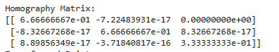

**OUTPUT:**

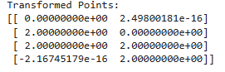

**16. Perform Edge detection using canny method**

**AIM:**

To detect edges in an image using the Canny edge detection algorithm.

**PROGRAM:**

!pip install opencv-python-headless matplotlib

import cv2

import numpy as np

import matplotlib.pyplot as plt

from google.colab import files

uploaded = files.upload()

image_path = list(uploaded.keys())[0]

image = cv2.imread(image_path)

gray_image = cv2.cvtColor(image, cv2.COLOR_BGR2GRAY)

blurred_image = cv2.GaussianBlur(gray_image, (5, 5), 0)

low_threshold = 50

high_threshold = 150

edges = cv2.Canny(blurred_image, low_threshold, high_threshold)

plt.figure(figsize=(10, 5))

plt.subplot(1, 2, 1)

plt.imshow(cv2.cvtColor(image, cv2.COLOR_BGR2RGB))

plt.title("Original Image")

plt.axis('off')

plt.subplot(1, 2, 2)

plt.imshow(edges, cmap='gray')

plt.title("Edge Detection (Canny)")

plt.axis('off')

plt.show()

**INPUT:**

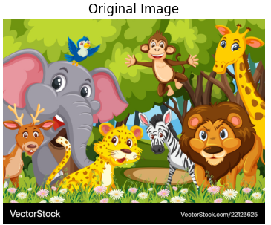

**OUTPUT:**

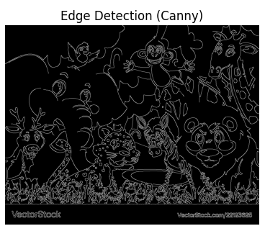

**17. Perform Edge detection using Sobel Matrix along X axis**

**AIM:**

To detect edges in an image by applying the Sobel operator along the X-axis for horizontal gradient computation.

**PROGRAM:**

!pip install matplotlib opencv-python-headless

import cv2

import numpy as np

import matplotlib.pyplot as plt

from google.colab import files

uploaded = files.upload()

image_path = list(uploaded.keys())[0]

image = cv2.imread(image_path, cv2.IMREAD_GRAYSCALE)

sobel_x = cv2.Sobel(image, cv2.CV_64F, 1, 0, ksize=3)

sobel_x = cv2.convertScaleAbs(sobel_x)

plt.figure(figsize=(10,5))

plt.subplot(1, 2, 1)

plt.imshow(image, cmap='gray')

plt.title('Original Image')

plt.axis('off')

plt.subplot(1, 2, 2)

plt.imshow(sobel_x, cmap='gray')

plt.title('Edge Detection (Sobel X-axis)')

plt.axis('off')

plt.show()

**INPUT:**

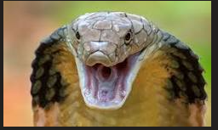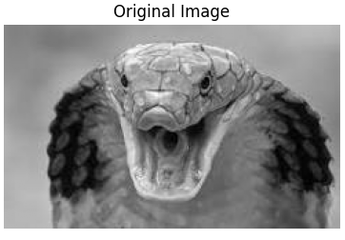

**OUTPUT:**

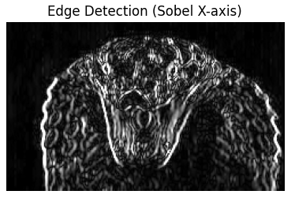

**18. Perform Edge detection using Sobel Matrix along Y axis**

**AIM:**

To detect edges in an image by applying the Sobel operator along the Y-axis for vertical gradient computation.

**PROGRAM:**

!pip install matplotlib opencv-python-headless

import cv2

import numpy as np

import matplotlib.pyplot as plt

from google.colab import files

uploaded = files.upload()

image_path = list(uploaded.keys())[0]

image = cv2.imread(image_path, cv2.IMREAD_GRAYSCALE)

sobel_y = cv2.Sobel(image, cv2.CV_64F, 0, 1, ksize=3)

sobel_y = cv2.convertScaleAbs(sobel_y)

plt.figure(figsize=(10,5))

plt.subplot(1, 2, 1)

plt.imshow(image, cmap='gray')

plt.title('Original Image')

plt.axis('off')

plt.subplot(1, 2, 2)

plt.imshow(sobel_y, cmap='gray')

plt.title('Edge Detection (Sobel Y-axis)')

plt.axis('off')

plt.show()

**INPUT:**

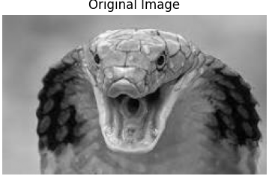

**OUTPUT:**

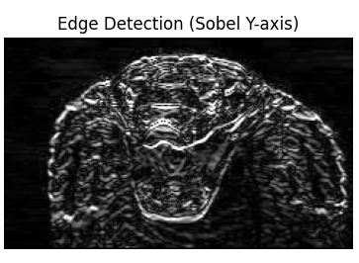

**19. Perform Edge detection using Sobel Matrix along XY axis**

**AIM:**

To detect edges in an image by applying the Sobel operator along both X and Y axes for combined gradient magnitude computation.

**PROGRAM:**

!pip install matplotlib opencv-python-headless

import cv2

import numpy as np

import matplotlib.pyplot as plt

from google.colab import files

uploaded = files.upload()

image_path = list(uploaded.keys())[0]

image = cv2.imread(image_path, cv2.IMREAD_GRAYSCALE)

sobel_x = cv2.Sobel(image, cv2.CV_64F, 1, 0, ksize=3)

sobel_y = cv2.Sobel(image, cv2.CV_64F, 0, 1, ksize=3)

sobel_x = cv2.convertScaleAbs(sobel_x)

sobel_y = cv2.convertScaleAbs(sobel_y)

plt.figure(figsize=(15, 5))

plt.subplot(1, 3, 1)

plt.imshow(image, cmap='gray')

plt.title('Original Image')

plt.axis('off')

plt.subplot(1, 3, 2)

plt.imshow(sobel_x, cmap='gray')

plt.title('Sobel X (Horizontal Edges)')

plt.axis('off')

plt.subplot(1, 3, 3)

plt.imshow(sobel_y, cmap='gray')

plt.title('Sobel Y (Vertical Edges)')

plt.axis('off')

plt.tight_layout()

plt.show()

**INPUT:**

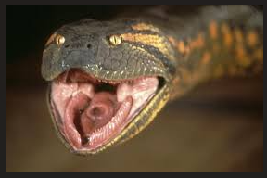

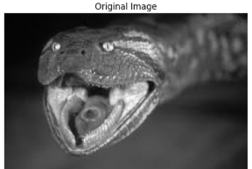

**OUTPUT:**

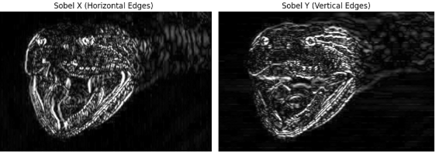

**20. Perform Sharpening of Image using Laplacian mask with negative center coefficient.**

**AIM:**

To sharpen an image by applying a Laplacian mask with a negative center coefficient for edge enhancement.

**PROGRAM:**

import cv2

import numpy as np

import matplotlib.pyplot as plt

from google.colab.patches import cv2_imshow

from google.colab import files

uploaded = files.upload()

for filename in uploaded.keys():

image_path = filename

image = cv2.imread(image_path, cv2.IMREAD_GRAYSCALE)

laplacian_kernel = np.array([[0, 1, 0],

[1, -4, 1],

[0, 1, 0]])

laplacian = cv2.filter2D(image, -1, laplacian_kernel)

sharpened = cv2.subtract(image, laplacian)

plt.figure(figsize=(12, 4))

plt.subplot(1, 3, 1)

plt.title("Original Image")

plt.imshow(image, cmap='gray')

plt.axis('off')

plt.subplot(1, 3, 2)

plt.title("Laplacian")

plt.imshow(laplacian, cmap='gray')

plt.axis('off')

plt.subplot(1, 3, 3)

plt.title("Sharpened Image")

plt.imshow(sharpened, cmap='gray')

plt.axis('off')

plt.show()

**INPUT:**

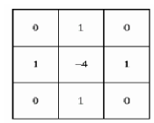

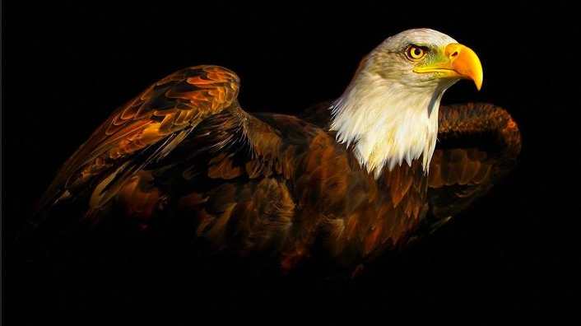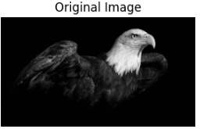

**OUTPUT:**

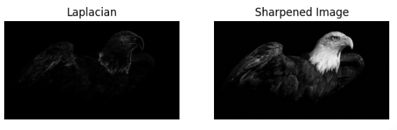

**21. Perform Sharpening of Image using Laplacian mask implemented with an extension of diagonal neighbors.**

**AIM:**

To sharpen an image using an extended Laplacian mask (including diagonal neighbors) for enhanced edge detection and detail highlighting.

**PROGRAM:**

import cv2

import numpy as np

import matplotlib.pyplot as plt

from google.colab import files

uploaded = files.upload()

for filename in uploaded.keys():

image_path = filename

image = cv2.imread(image_path, cv2.IMREAD_GRAYSCALE)

laplacian_kernel = np.array([[1, 1, 1],

[1, -8, 1],

[1, 1, 1]])

laplacian = cv2.filter2D(image, -1, laplacian_kernel)

sharpened = cv2.subtract(image, laplacian)

plt.figure(figsize=(12, 4))

plt.subplot(1, 3, 1)

plt.title("Original")

plt.imshow(image, cmap='gray')

plt.axis('off')

plt.subplot(1, 3, 2)

plt.title("Laplacian (8-neighbor)")

plt.imshow(laplacian, cmap='gray')

plt.axis('off')

plt.subplot(1, 3, 3)

plt.title("Sharpened")

plt.imshow(sharpened, cmap='gray')

plt.axis('off')

plt.show()

**INPUT:**

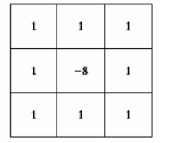

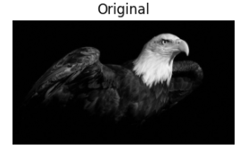

**OUTPUT:**

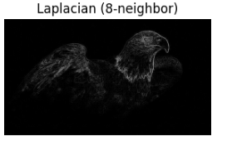

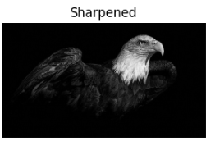

**22. Perform Sharpening of Image using Laplacian mask with positive center coefficient.**

**AIM:**

To sharpen an image using a Laplacian mask with a positive center coefficient for edge enhancement and detail highlighting.

**PROGRAM:**

import cv2

import numpy as np

import matplotlib.pyplot as plt

from google.colab import files

uploaded = files.upload()

image_path = next(iter(uploaded))

image = cv2.imread(image_path)

gray_image = cv2.cvtColor(image, cv2.COLOR_BGR2GRAY)

laplacian_kernel = np.array([[0, -1, 0],

[-1, 5, -1],

[0, -1, 0]])

sharpened_image = cv2.filter2D(gray_image, -1, laplacian_kernel)

plt.figure(figsize=(10, 5))

plt.subplot(1, 2, 1)

plt.imshow(gray_image, cmap='gray')

plt.title("Original Grayscale Image")

plt.axis('off')

plt.subplot(1, 2, 2)

plt.imshow(sharpened_image, cmap='gray')

plt.title("Sharpened Image using Laplacian")

plt.axis('off')

plt.tight_layout()

plt.show()

**INPUT:**

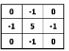



**OUTPUT:**

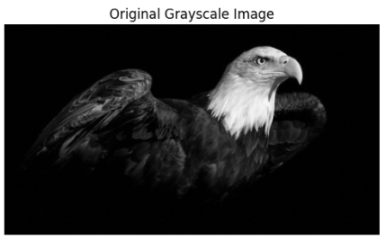

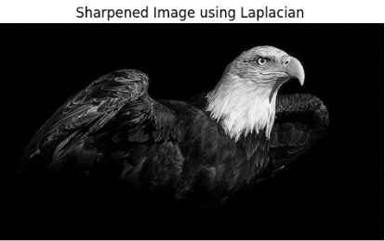

**23. Perform Sharpening of Image using unsharp masking.**

**AIM:**

To sharpen an image using the unsharp masking technique by enhancing edge contrast through blurred image subtraction.

**PROGRAM**:

import cv2

import numpy as np

import matplotlib.pyplot as plt

from google.colab import files

uploaded = files.upload()

image_path = next(iter(uploaded))

image = cv2.imread(image_path)

gray = cv2.cvtColor(image, cv2.COLOR_BGR2GRAY)

blurred = cv2.GaussianBlur(gray, (5, 5), 0)

mask = cv2.subtract(gray, blurred)

sharpened = cv2.add(gray, mask) *# k=1, so sharpened = original + mask*

plt.figure(figsize=(10, 5))

plt.subplot(1, 2, 1)

plt.imshow(gray, cmap='gray')

plt.title("Original Grayscale Image")

plt.axis('off')

plt.subplot(1, 2, 2)

plt.imshow(sharpened, cmap='gray')

plt.title("Sharpened Image (Unsharp Masking)")

plt.axis('off')

plt.tight_layout()

plt.show()

**INPUT:**



**OUTPUT:**

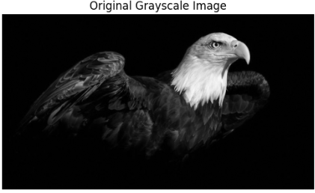

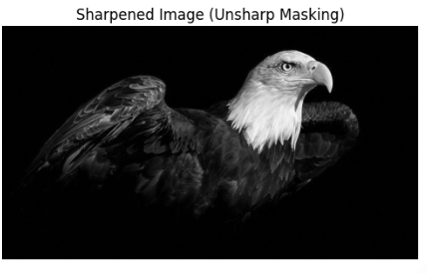

**24. Perform Sharpening of Image using High-Boost Masks.**

**AIM:**

To sharpen an image using High-Boost Masks by amplifying high-frequency details while preserving the original image content.

**PROGRAM:**

!pip install opencv-python-headless matplotlib

import cv2

import numpy as np

import matplotlib.pyplot as plt

from google.colab import files

from PIL import Image

import io

uploaded = files.upload()

for filename in uploaded.keys():

image_path = filename

image = cv2.imread(image_path, cv2.IMREAD_GRAYSCALE)

A = 2

*high-boost)*

high_boost_kernel = np.array([

[-1, -1, -1],

[-1, A + 8, -1],

[-1, -1, -1]

])

sharpened = cv2.filter2D(image, -1, high_boost_kernel)

plt.figure(figsize=(10, 4))

plt.subplot(1, 2, 1)

plt.title("Original Image")

plt.imshow(image, cmap='gray')

plt.axis('off')

plt.subplot(1, 2, 2)

plt.title(f"High-Boost Sharpened (A={A})")

plt.imshow(sharpened, cmap='gray')

plt.axis('off')

plt.tight_layout()

plt.show()

**INPUT:**

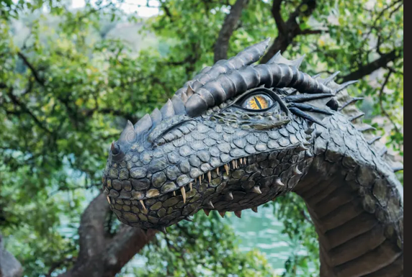

**OUTPUT:**

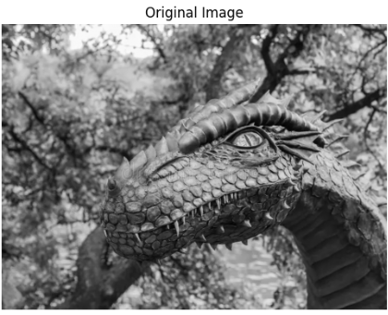

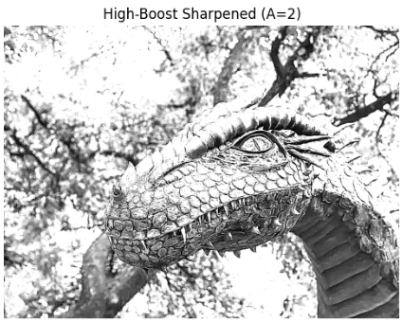

**25. Perform Sharpening of Image using Gradient masking.**

**AIM:**

To sharpen an image using Gradient Masking by emphasizing edges through directional gradient operators.

**PROGRAM:**

!pip install opencv-python-headless matplotlib

import cv2

import numpy as np

import matplotlib.pyplot as plt

from google.colab import files

uploaded = files.upload()

for filename in uploaded.keys():

image_path = filename

image = cv2.imread(image_path, cv2.IMREAD_GRAYSCALE)

kernel_x = np.array([

[-1, 0, 1],

[-2, 0, 2],

[-1, 0, 1]

])

kernel_y = np.array([

[-1, -2, -1],

[ 0, 0, 0],

[ 1, 2, 1]

])

grad_x = cv2.filter2D(image, -1, kernel_x)

grad_y = cv2.filter2D(image, -1, kernel_y)

gradient_magnitude = cv2.addWeighted(cv2.convertScaleAbs(grad_x), 0.5,

cv2.convertScaleAbs(grad_y), 0.5, 0)

sharpened = cv2.add(image, gradient_magnitude)

plt.figure(figsize=(12, 4))

plt.subplot(1, 3, 1)

plt.title("Original")

plt.imshow(image, cmap='gray')

plt.axis('off')

plt.subplot(1, 3, 2)

plt.title("Edge Magnitude")

plt.imshow(gradient_magnitude, cmap='gray')

plt.axis('off')

plt.subplot(1, 3, 3)

plt.title("Sharpened Image")

plt.imshow(sharpened, cmap='gray')

plt.axis('off')

plt.tight_layout()

plt.show()

**INPUT:**

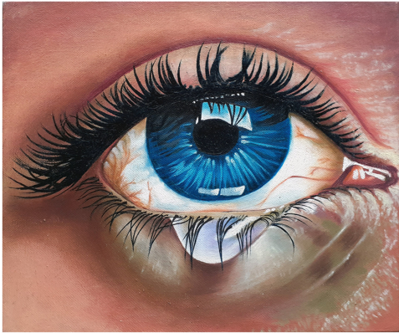

**OUTPUT:**

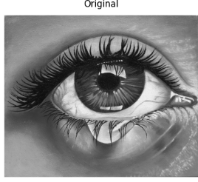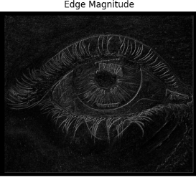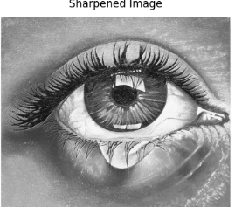

**26. Insert water marking to the image using OpenCV.**

**AIM:**

To embed a visible or invisible watermark into an image using OpenCV for copyright protection or branding.

**PROGRAM:**

!pip install opencv-python-headless matplotlib

import cv2

import numpy as np

import matplotlib.pyplot as plt

from google.colab import files

uploaded = files.upload()

for filename in uploaded.keys():

image_path = filename

image = cv2.imread(image_path)

image = cv2.cvtColor(image, cv2.COLOR_BGR2RGB)

watermark_text = "parameswari.R"

(h, w) = image.shape[:2]

position = (w - 200, h - 20)

watermarked_image = image.copy()

cv2.putText(

watermarked_image,

watermark_text,

position,

fontFace=cv2.FONT_HERSHEY_SIMPLEX,

fontScale=1,

color=(255, 255, 255), *# White text*

thickness=2,

lineType=cv2.LINE_AA

)

blended = cv2.addWeighted(image, 0.8, watermarked_image, 0.2, 0)

plt.figure(figsize=(10, 5))

plt.subplot(1, 2, 1)

plt.title("Original")

plt.imshow(image)

plt.axis('off')

plt.subplot(1, 2, 2)

plt.title("Watermarked")

plt.imshow(blended)

plt.axis('off')

plt.tight_layout()

plt.show()

**INPUT: OUTPUT:**

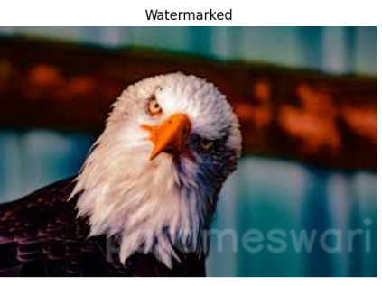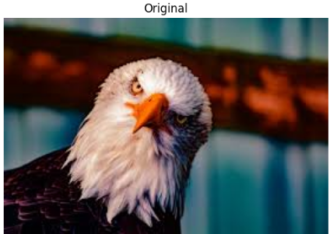

**27. Do Cropping, Copying and pasting image inside another image using OpenCV.**

**AIM:**

To crop a region from one image and paste it onto another image using OpenCV for seamless image composition.

**PROGRAM:**

!pip install opencv-python-headless matplotlib

import cv2

import numpy as np

import matplotlib.pyplot as plt

from google.colab import files

uploaded = files.upload()

for filename in uploaded.keys():

image_path = filename

image = cv2.imread(image_path)

image_rgb = cv2.cvtColor(image, cv2.COLOR_BGR2RGB)

cropped = image_rgb[50:150, 100:200]

image_copy = image_rgb.copy()

h, w, _ = cropped.shape

image_copy[-h-10:-10, -w-10:-10] = cropped

plt.figure(figsize=(12, 4))

plt.subplot(1, 3, 1)

plt.title("Original Image")

plt.imshow(image_rgb)

plt.axis('off')

plt.subplot(1, 3, 2)

plt.title("Cropped Part")

plt.imshow(cropped)

plt.axis('off')

plt.subplot(1, 3, 3)

plt.title("After Pasting")

plt.imshow(image_copy)

plt.axis('off')

plt.tight_layout()

plt.show()

**INPUT:**

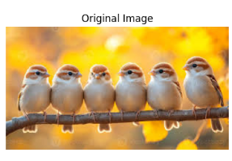

**OUTPUT:**

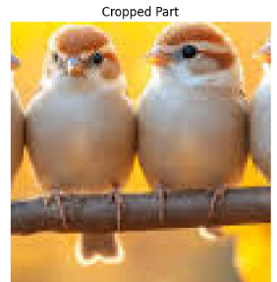

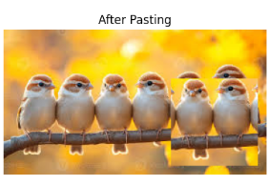

**28. Find the boundary of the image using Convolution kernel for the given image.**

**AIM:**

To detect the boundaries of an image by applying a convolution kernel for edge extraction.

**PROGRAM:**

!pip install opencv-python-headless matplotlib

import cv2

import numpy as np

import matplotlib.pyplot as plt

from google.colab import files

uploaded = files.upload()

for filename in uploaded.keys():

image_path = filename

image = cv2.imread(image_path, cv2.IMREAD_GRAYSCALE)

kernel = np.array([[0, -1, 0],

[-1, 4, -1],

[0, -1, 0]])

boundary = cv2.filter2D(image, -1, kernel)

plt.figure(figsize=(10, 5))

plt.subplot(1, 2, 1)

plt.title("Original Image")

plt.imshow(image, cmap='gray')

plt.axis('off')

plt.subplot(1, 2, 2)

plt.title("Boundary Detected")

plt.imshow(boundary, cmap='gray')

plt.axis('off')

plt.tight_layout()

plt.show()

**INPUT:**

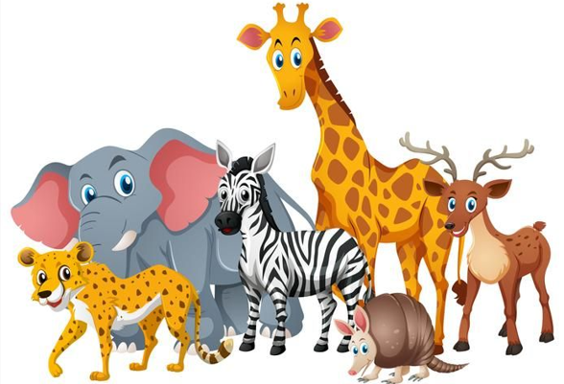

**OUTPUT:**

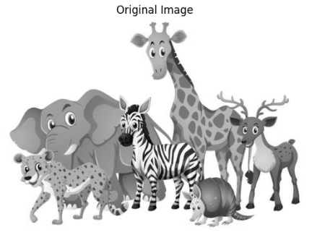

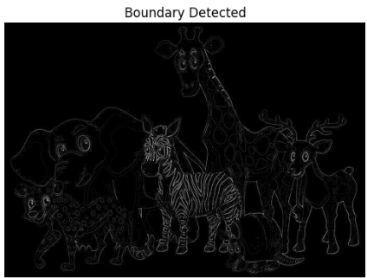

**29. Morphological operations based on OpenCV using Erosion technique.**

**AIM:**

Morphological operations based on OpenCV using Erosion technique.

**Program:**

import cv2

import numpy as np

from matplotlib import pyplot as plt

image = cv2.imread('1.png', cv2.IMREAD_GRAYSCALE)

_, binary = cv2.threshold(image, 127, 255, cv2.THRESH_BINARY)

kernel = np.ones((5, 5), np.uint8)

eroded = cv2.erode(binary, kernel, iterations=1)

cv2.imwrite('5.png', eroded)

plt.figure(figsize=(10, 4))

plt.subplot(1, 2, 1)

plt.title("Original Binary")

plt.imshow(binary, cmap='gray')

plt.axis('off')

plt.subplot(1, 2, 2)

plt.title("Eroded Image")

plt.imshow(eroded, cmap='gray')

plt.axis('off')

plt.tight_layout()

plt.show()

**Output:**

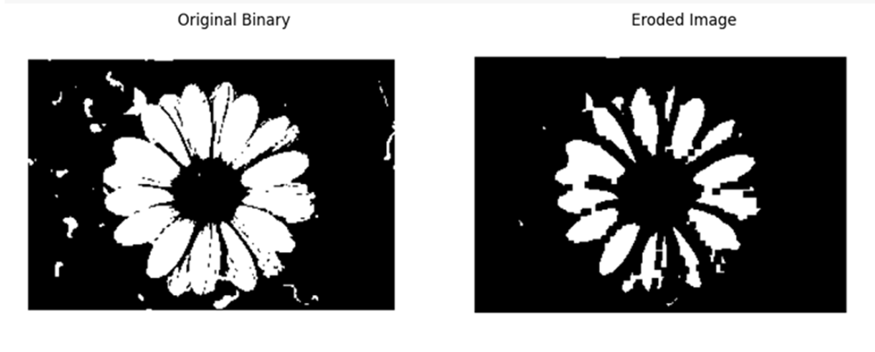

**30. Morphological operations based on OpenCV using Dilation technique.**

**AIM:** Morphological operations based on OpenCV using Dilation technique.

**PROGRAM:**

import cv2

import numpy as np

from matplotlib import pyplot as plt

image = cv2.imread('1.png', cv2.IMREAD_GRAYSCALE)

_, binary = cv2.threshold(image, 127, 255, cv2.THRESH_BINARY)

kernel = np.ones((5, 5), np.uint8)

dilated = cv2.dilate(binary, kernel, iterations=1)

cv2.imwrite('6.png', dilated)

plt.figure(figsize=(10, 4))

plt.subplot(1, 2, 1)

plt.title("Original Binary")

plt.imshow(binary, cmap='gray')

plt.axis('off')

plt.subplot(1, 2, 2)

plt.title("Dilated Image")

plt.imshow(dilated, cmap='gray')

plt.axis('off')

plt.tight_layout()

plt.show()

**OUTPUT:**

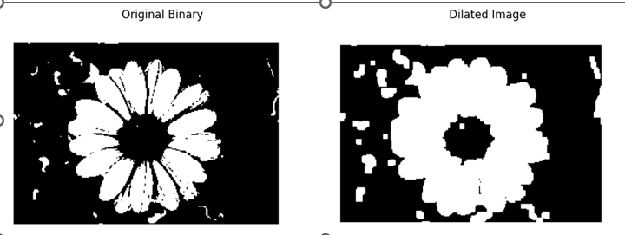

**31. Morphological operations based on OpenCV using Opening technique.**

**AIM:** Morphological operations based on OpenCV using Opening technique.

**PROGRAM:**

import cv2

import numpy as np

from matplotlib import pyplot as plt

image = cv2.imread('1.png', cv2.IMREAD_GRAYSCALE)

_, binary = cv2.threshold(image, 127, 255, cv2.THRESH_BINARY)

kernel = np.ones((5, 5), np.uint8)

opened = cv2.morphologyEx(binary, cv2.MORPH_OPEN, kernel)

cv2.imwrite('7.png', opened)

plt.figure(figsize=(10, 4))

plt.subplot(1, 2, 1)

plt.title("Original Binary")

plt.imshow(binary, cmap='gray')

plt.axis('off')

plt.subplot(1, 2, 2)

plt.title("After Opening")

plt.imshow(opened, cmap='gray')

plt.axis('off')

plt.tight_layout()

plt.show()

**OUTPUT:**

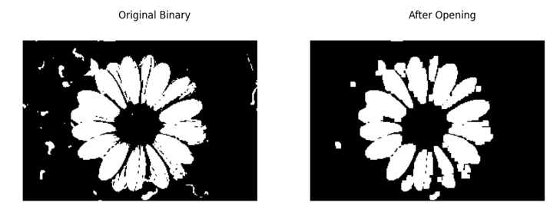

**32. Morphological operations based on OpenCV using Closing technique.**

**AIM:** Morphological operations based on OpenCV using Closing technique.

**PROGRAM:**

import cv2

import numpy as np

from matplotlib import pyplot as plt

image = cv2.imread('1.png', cv2.IMREAD_GRAYSCALE)

_, binary = cv2.threshold(image, 127, 255, cv2.THRESH_BINARY)

kernel = np.ones((5, 5), np.uint8)

closed = cv2.morphologyEx(binary, cv2.MORPH_CLOSE, kernel)

cv2.imwrite('8.png', closed)

plt.figure(figsize=(10, 4))

plt.subplot(1, 2, 1)

plt.title("Original Binary")

plt.imshow(binary, cmap='gray')

plt.axis('off')

plt.subplot(1, 2, 2)

plt.title("After Closing")

plt.imshow(closed, cmap='gray')

plt.axis('off')

plt.tight_layout()

plt.show()

**OUTPUT:**

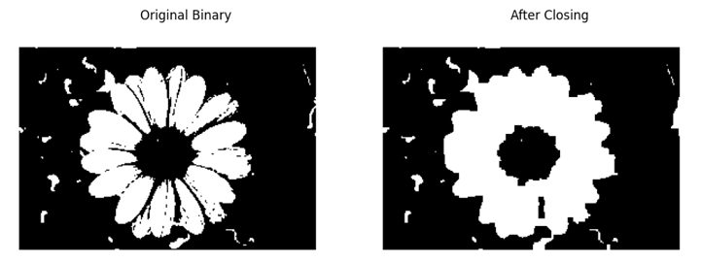

**33. Morphological operations based on OpenCV using Morphological Gradient technique.**

**AIM:** Morphological operations based on OpenCV using Morphological Gradient technique.

**PROGRAM:**

import cv2

import numpy as np

from matplotlib import pyplot as plt

image = cv2.imread('1.png', cv2.IMREAD_GRAYSCALE)

_, binary = cv2.threshold(image, 127, 255, cv2.THRESH_BINARY)

kernel = np.ones((5, 5), np.uint8)

gradient = cv2.morphologyEx(binary, cv2.MORPH_GRADIENT, kernel)

cv2.imwrite('9.png', gradient)

plt.figure(figsize=(10, 4))

plt.subplot(1, 2, 1)

plt.title("Original Binary")

plt.imshow(binary, cmap='gray')

plt.axis('off')

plt.subplot(1, 2, 2)

plt.title("Morphological Gradient")

plt.imshow(gradient, cmap='gray')

plt.axis('off')

plt.tight_layout()

plt.show()

**OUTPUT:**

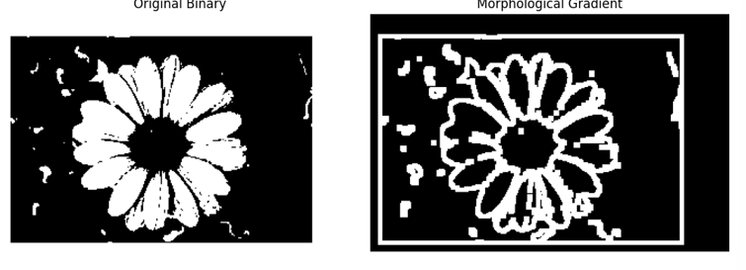

**34. Morphological operations based on OpenCV using Top hat technique.**

**AIM:**Morphological operations based on OpenCV using Top hat technique.

**PROGRAM:**

import cv2

import numpy as np

from matplotlib import pyplot as plt

image = cv2.imread('1.png', 0)

kernel = cv2.getStructuringElement(cv2.MORPH_RECT, (15, 15))

top_hat = cv2.morphologyEx(image, cv2.MORPH_TOPHAT, kernel)

plt.subplot(1, 2, 1)

plt.title('Original Image')

plt.imshow(image, cmap='gray')

plt.subplot(1, 2, 2)

plt.title('Top Hat Result')

plt.imshow(top_hat, cmap='gray')

plt.show()

**OUTPUT:**

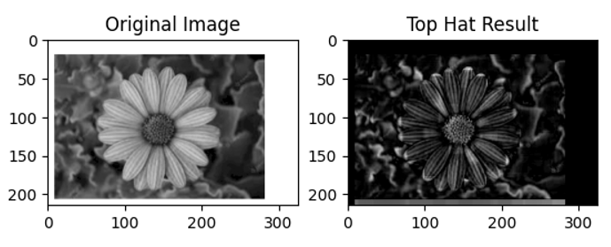

**35. Morphological operations based on OpenCV using Black hat technique.**

**AIM:** Morphological operations based on OpenCV using Black hat technique.

**PROGRAM:**

import cv2

import numpy as np

from matplotlib import pyplot as plt

image = cv2.imread('1.png', 0)

kernel = cv2.getStructuringElement(cv2.MORPH_RECT, (15, 15))

black_hat = cv2.morphologyEx(image, cv2.MORPH_BLACKHAT, kernel)

plt.subplot(1, 2, 1)

plt.title('Original Image')

plt.imshow(image, cmap='gray')

plt.subplot(1, 2, 2)

plt.title('Black Hat Result')

plt.imshow(black_hat, cmap='gray')

plt.show()

**OUTPUT:**

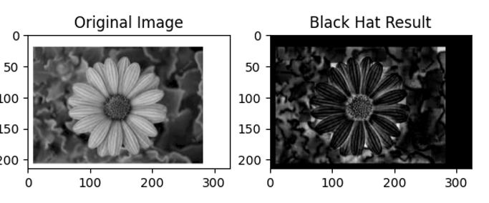

**36. Recognise watch from the given image by general Object recognition using OpenCV.**

**AIM:** Recognise watch from the given image by general Object recognition using OpenCV.

**PROGRAM:**

import cv2

import matplotlib.pyplot as plt

image = cv2.imread('1.png', cv2.IMREAD_GRAYSCALE)

orb = cv2.ORB_create(nfeatures=1000)

keypoints, descriptors = orb.detectAndCompute(image, None)

keypoint_image = cv2.drawKeypoints(image, keypoints, None, color=(0, 255, 0), flags=0)

plt.figure(figsize=(8, 6))

plt.title("Detected Keypoints (ORB) - Watch Recognition")

plt.imshow(keypoint_image, cmap='gray')

plt.axis('off')

plt.show()

**OUTPUT:**

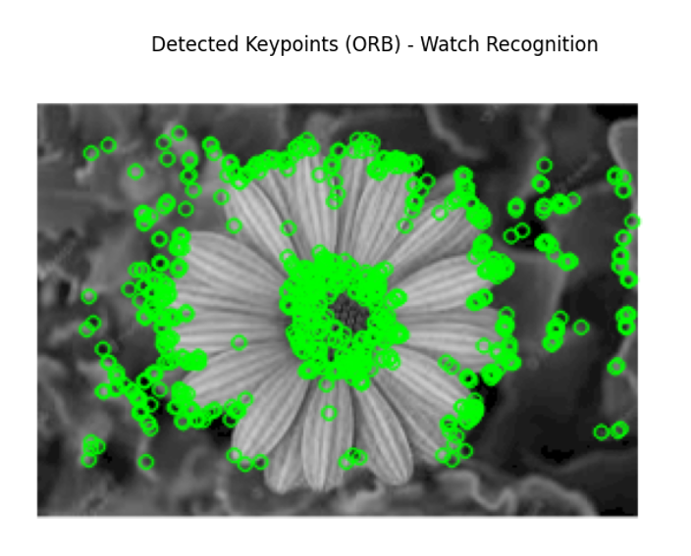

**37. Using Opencv play Video in Reverse mode.**

**AIM:** Using Opencv play Video in Reverse mode.

**PROGRAM:**

import cv2

from google.colab.patches import cv2_imshow

import time

video_path = 'videoplayback.mp4'

cap = cv2.VideoCapture(video_path)

if not cap.isOpened():

print("Error: Could not open video.")

exit()

frames = []

while True:

ret, frame = cap.read()

if not ret:

break

frames.append(frame)

cap.release()

for frame in reversed(frames):

cv2_imshow(frame)

time.sleep(0.03)

**OUTPUT:**

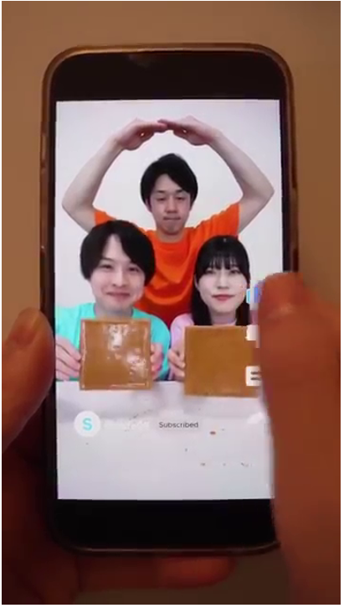

**38. Face Detection using Opencv.**

**AIM:** Face Detection using Opencv.

**PROGRAM:**

import cv2

face_cascade = cv2.CascadeClassifier(cv2.data.haarcascades + 'haarcascade_frontalface_default.xml')

image = cv2.imread('dd.png')

gray = cv2.cvtColor(image, cv2.COLOR_BGR2GRAY)

faces = face_cascade.detectMultiScale(gray, scaleFactor=1.1, minNeighbors=5)

for (x, y, w, h) in faces:

cv2.rectangle(image, (x, y), (x + w, y + h), (255, 0, 0), 2)

from google.colab.patches import cv2_imshow

cv2_imshow(image)

cv2.waitKey(0)

cv2.destroyAllWindows()

**OUTPUT:**

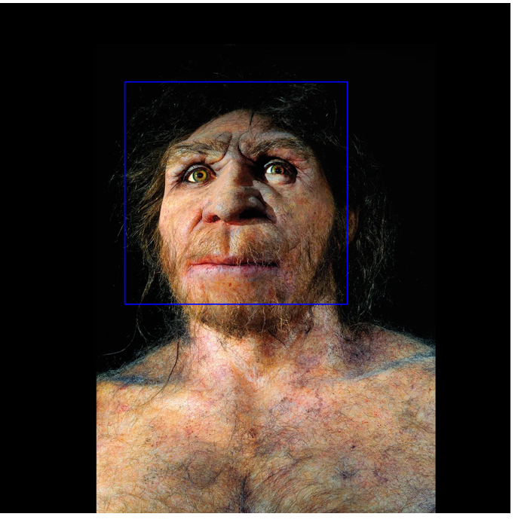

**40. Draw Rectangular shape and extract objects.**

**AIM:** Draw Rectangular shape and extract objects.

**PROGRAM:**

import cv2

from google.colab.patches import cv2_imshow

image = cv2.imread('12.png')

boxes = {

"Rohit Sharma": (100, 50, 150, 300),

"Virat Kohli": (300, 50, 150, 300)

}

for name, (x, y, w, h) in boxes.items():

cv2.rectangle(image, (x, y), (x + w, y + h), (255, 0, 0), 2)

cv2.putText(image, name, (x, y - 10), cv2.FONT_HERSHEY_SIMPLEX, 0.6, (255, 0, 0), 2)

cv2_imshow(image)

for name, (x, y, w, h) in boxes.items():

cropped = image[y:y+h, x:x+w]

print(f"Extracted: {name}")

cv2_imshow(cropped)

**OUTPUT:**

